Name: Pranali Sonawane
Subject: MCSA
Date: 10-12-2025
Lab: DNS

Server1: First Download DNS
Dashboard Add role and Features next next Click DNS Server next install.
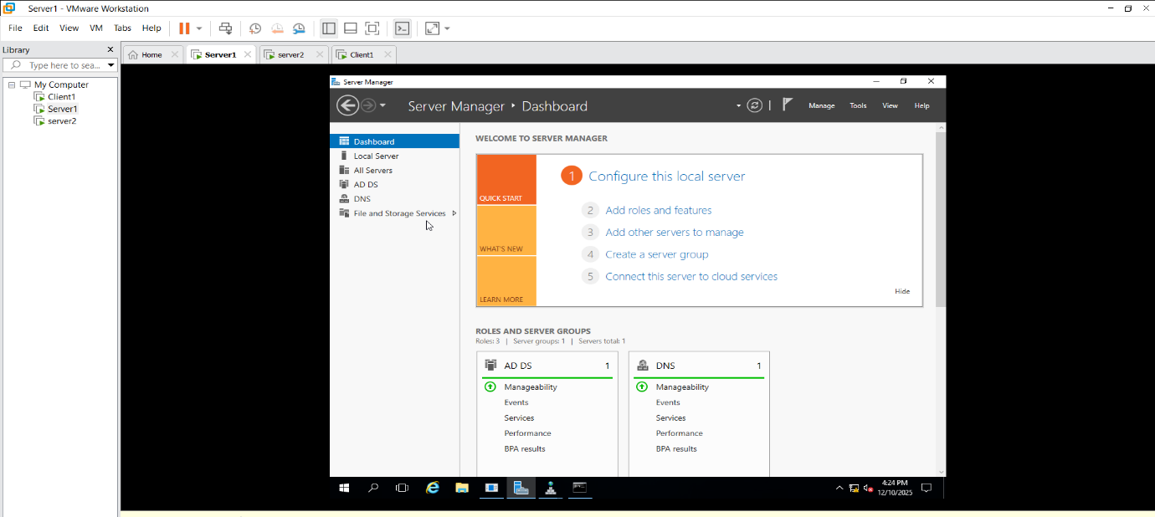

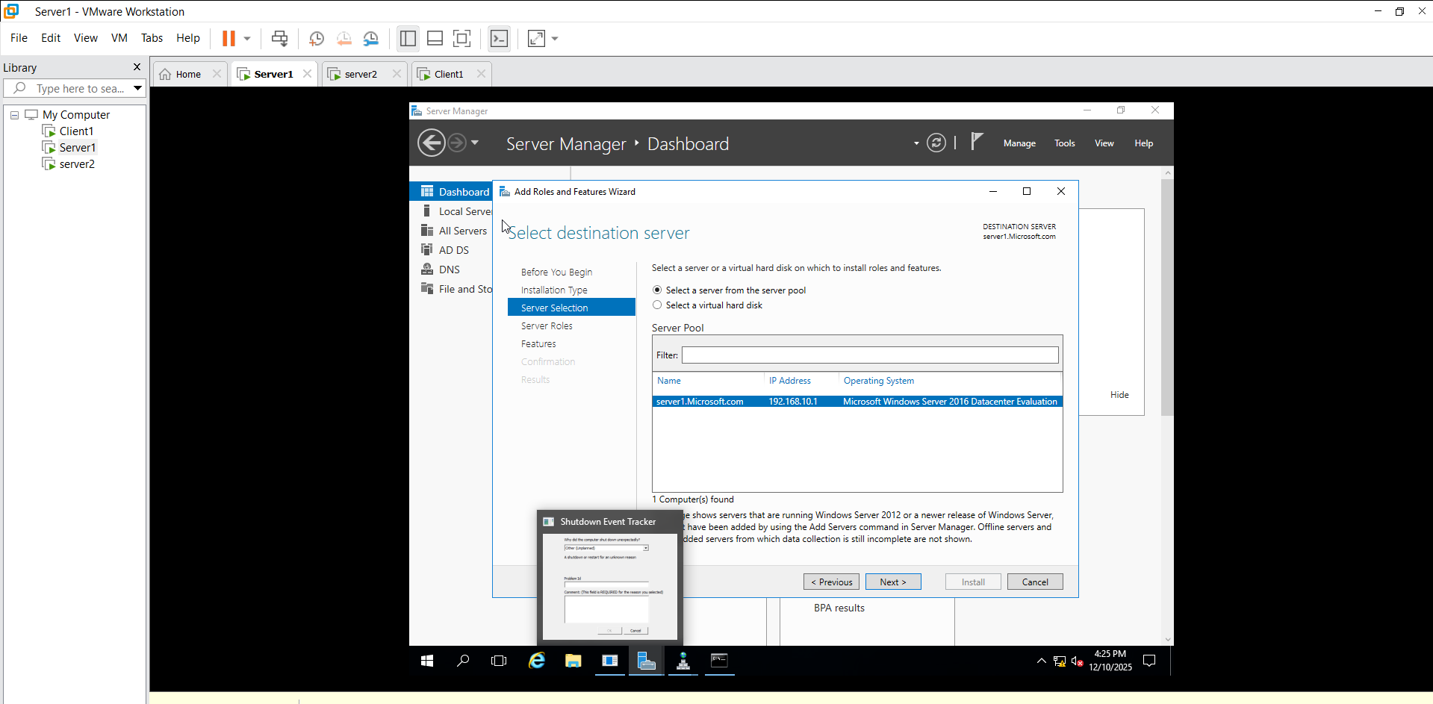
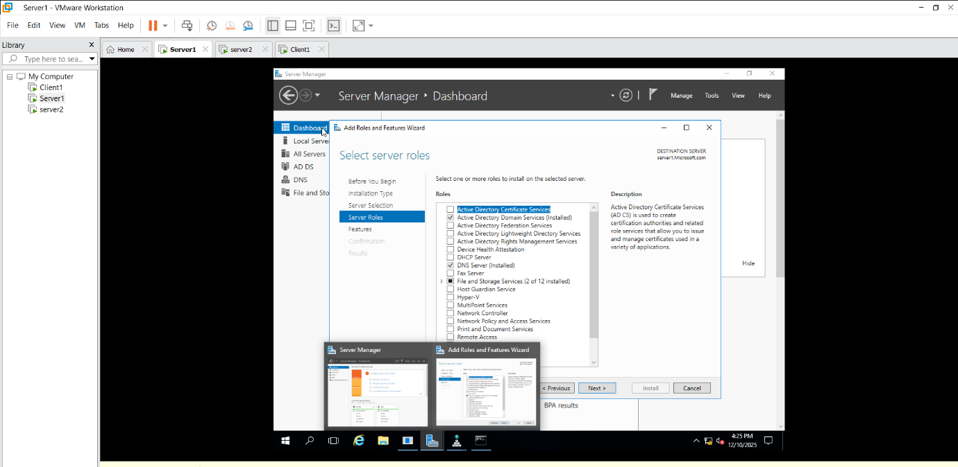

Tools Click on DNS Click on Server1 Create New Zone Primary Zone next Network ID: 192.168.10 next

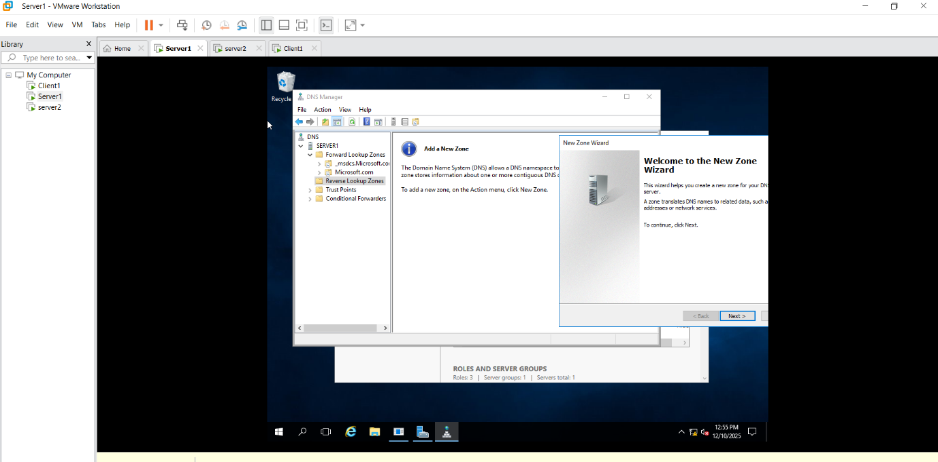
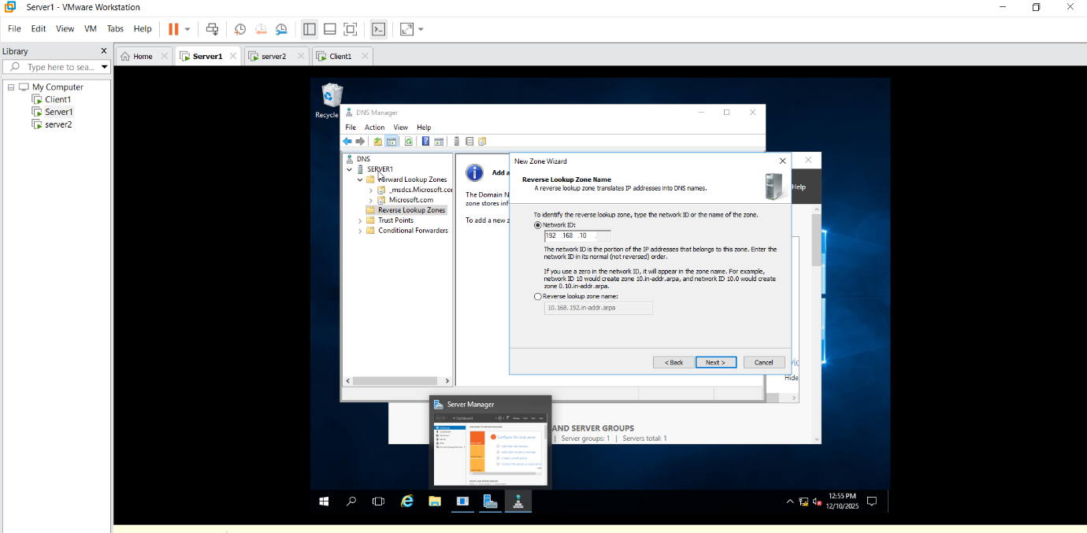
Tools Click on DNS Click on Server1 Show Forward Zone ,Reverse Zone

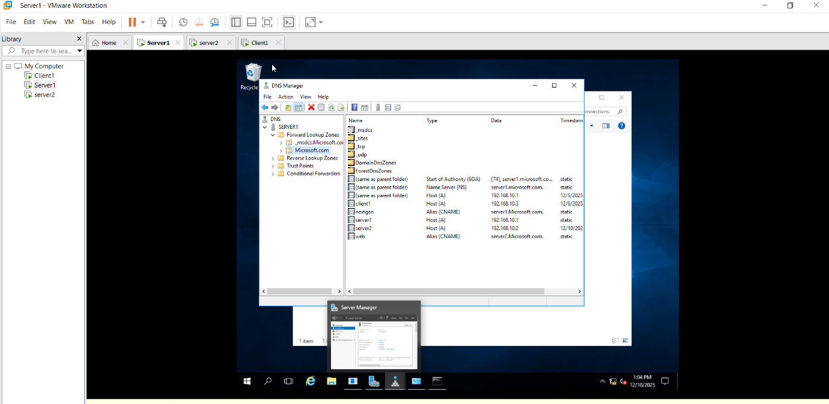

Forward Zone
Server1 Right Click Properties Click on Update(PTR Record) Server2 Right Click Properties Click on Update(PTR Record) Client1 Right Click Properties Click on Update(PTR Record)

Forward Zone Click on Microsoft.com CNAME give nextgen nextgen.microsoft.com Server1 Allow .
Forward Zone Click on Microsoft.com CNAME give web web.microsoft.com Server2 Allow.

Server1:
Run ncpa.cpl Ethernet0 IP 192.168.10.1, check dns server ip 192.168.10.1 ok disable enable

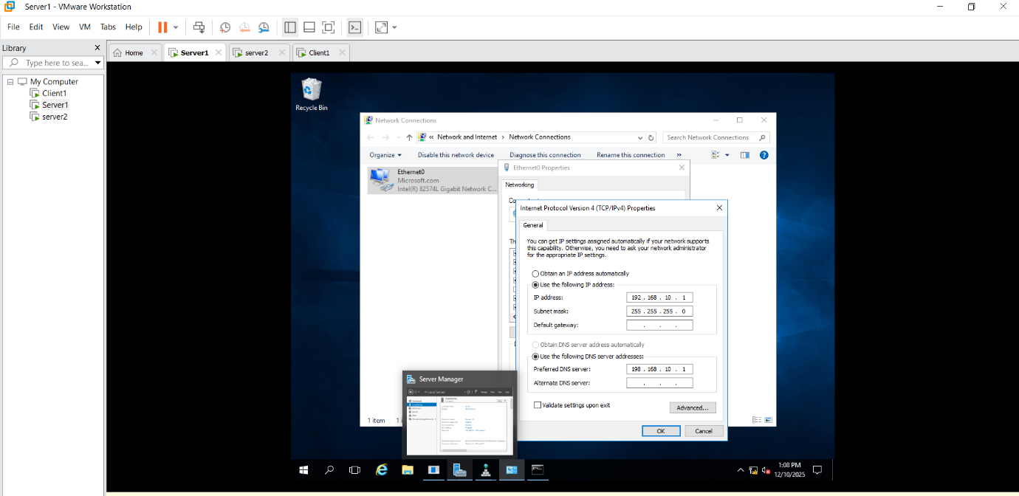
Dns server ip show 127.0.0.1 it’s loopback then give ip 192.168.10.1.

Server1 :
cmd: ping web
Ping server2

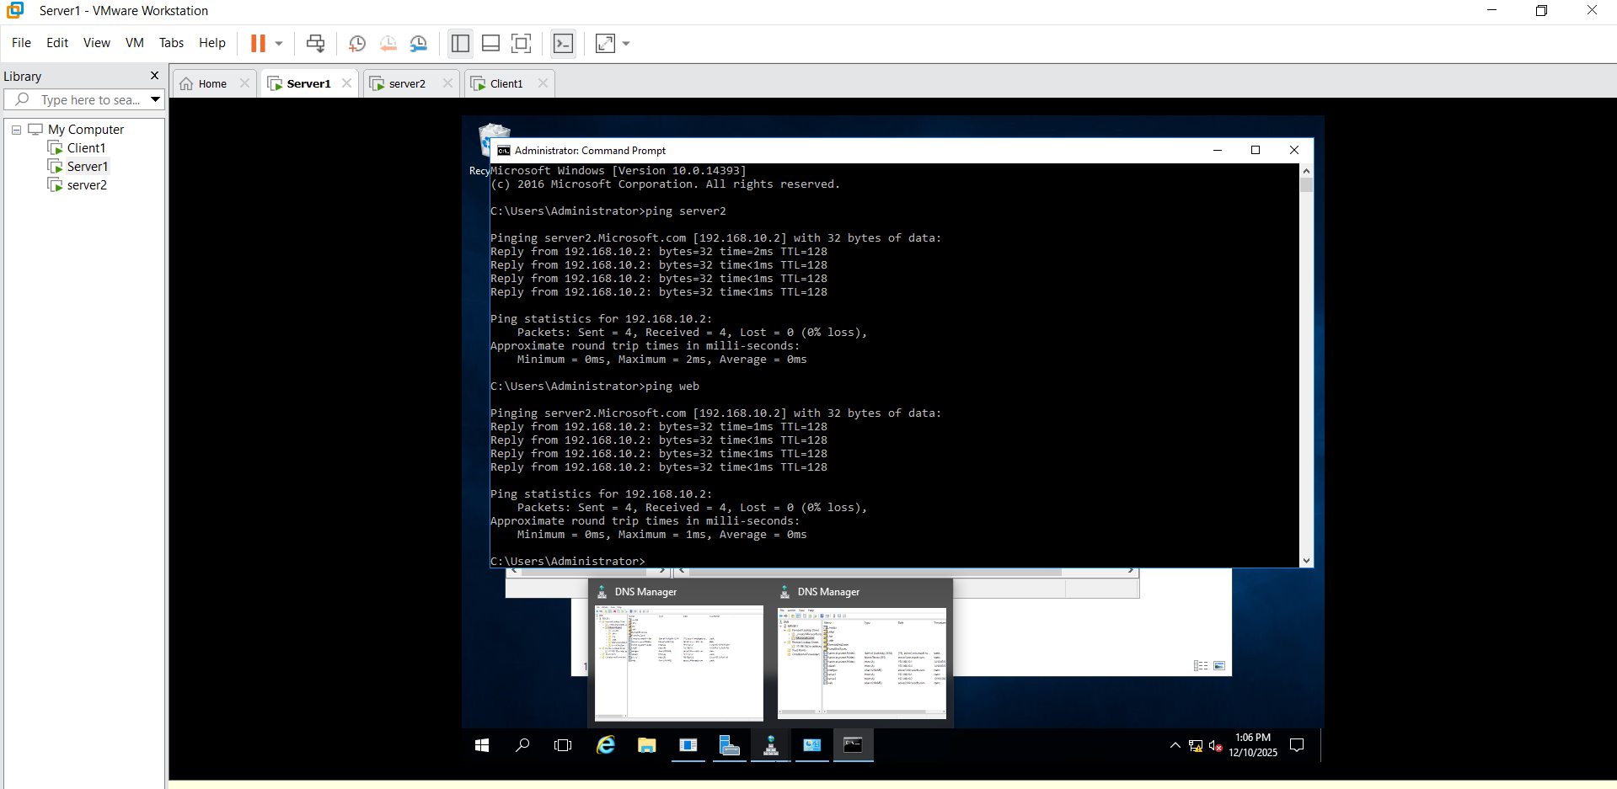
Server2:
Run ncpa.cpl Ethernet0 Alternate DNS remove then Ethernet0 disable enable
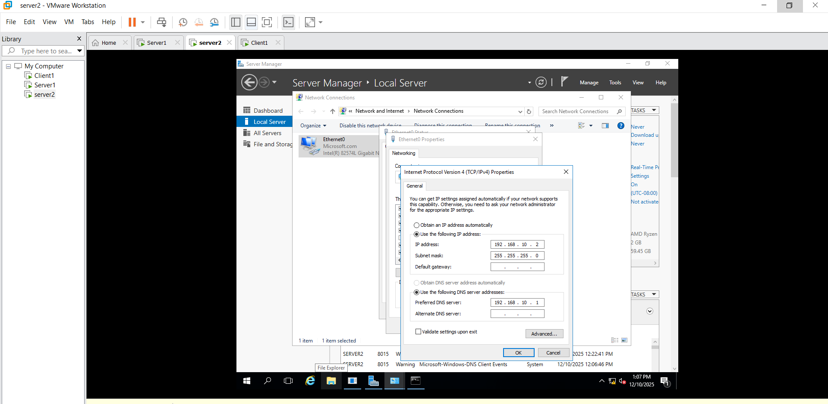
Cmd: Ping server1
Ping nextgen
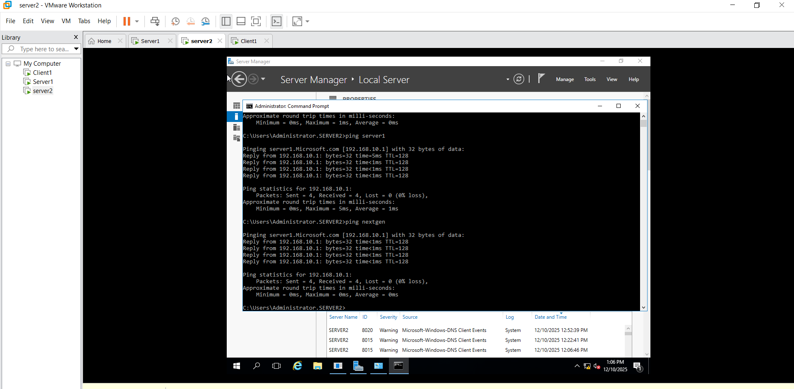

Server2: Secondary
- Add role and Feature next select DNS next install.
- Tools DNS Server2 new Zone click on Secondary Zone next Microsoft.com 192.168.10.1 next
- Server2 : Create 4 Folder: Forward Zone , Reverse Zone , Trust Points and Conditional Forwards
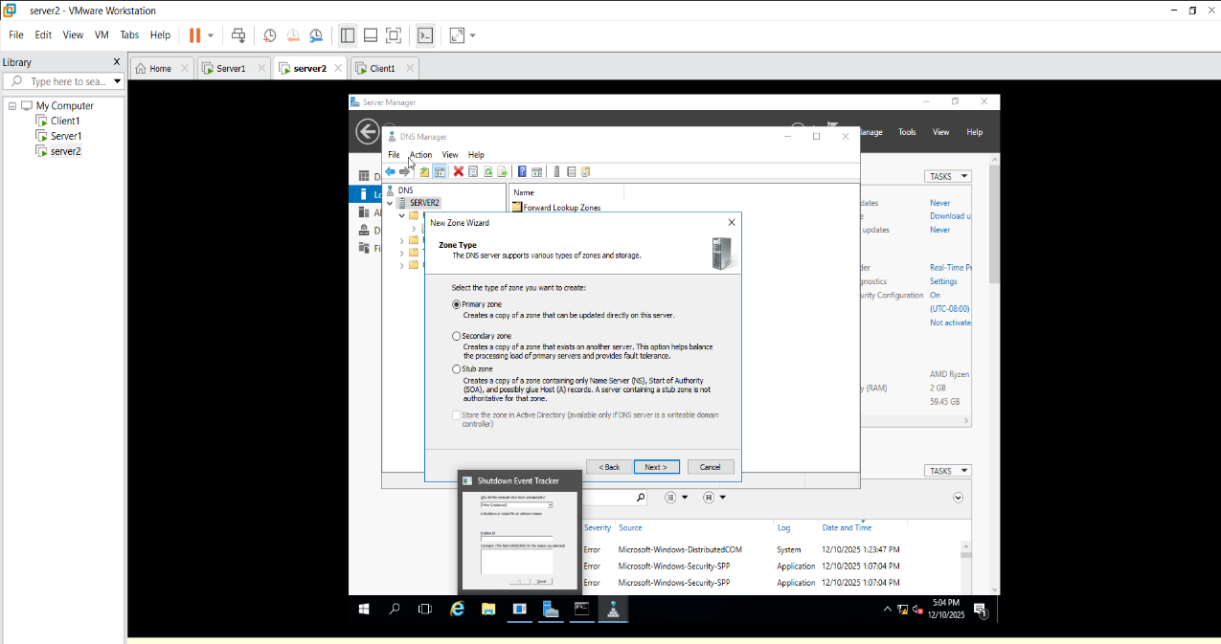

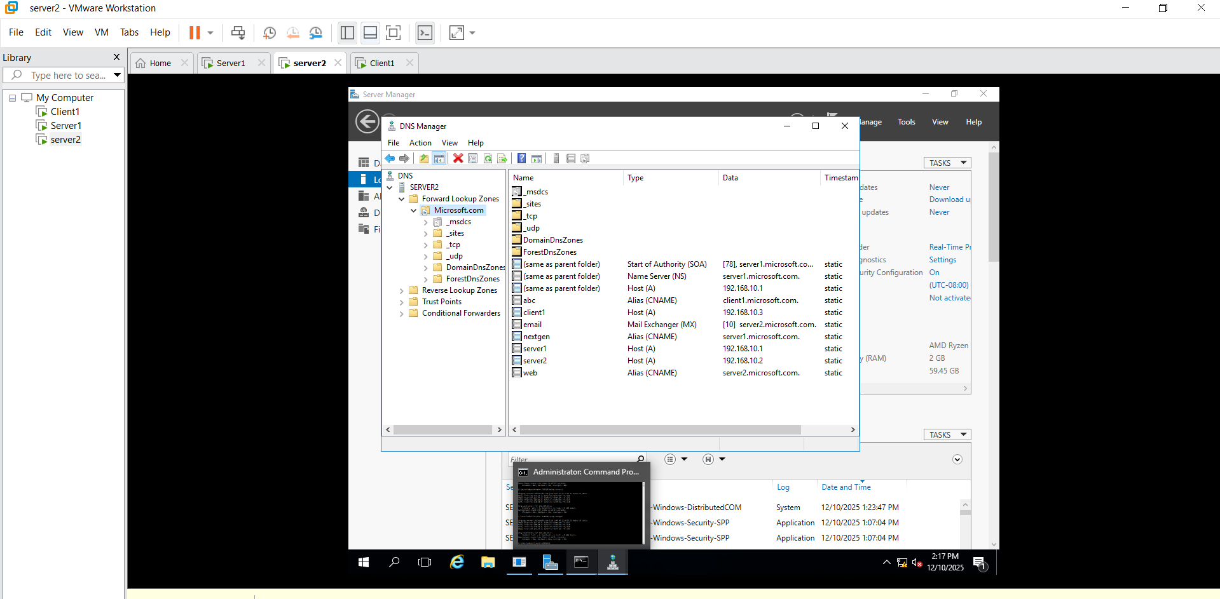

- Go to the Server1 : Forword Lookup Zone Microsoft.com Properties Transfer Zone Select To any Server next .
- In Server2 : Refresh Forword Zone Display the Server1 Forword Zone all File in Server2.
- Server2 Microsoft.com Transfer from master

- Go to the Server1 : Reverse Lookup Zone 10.168.192 Right click on Properties Transfer Zone Select To any Server next .
- In Server2 : Refresh Reverse Zone Display the Server1 Reverse Zone all File in Server2.
- Server2 Microsoft.com Transfer from master

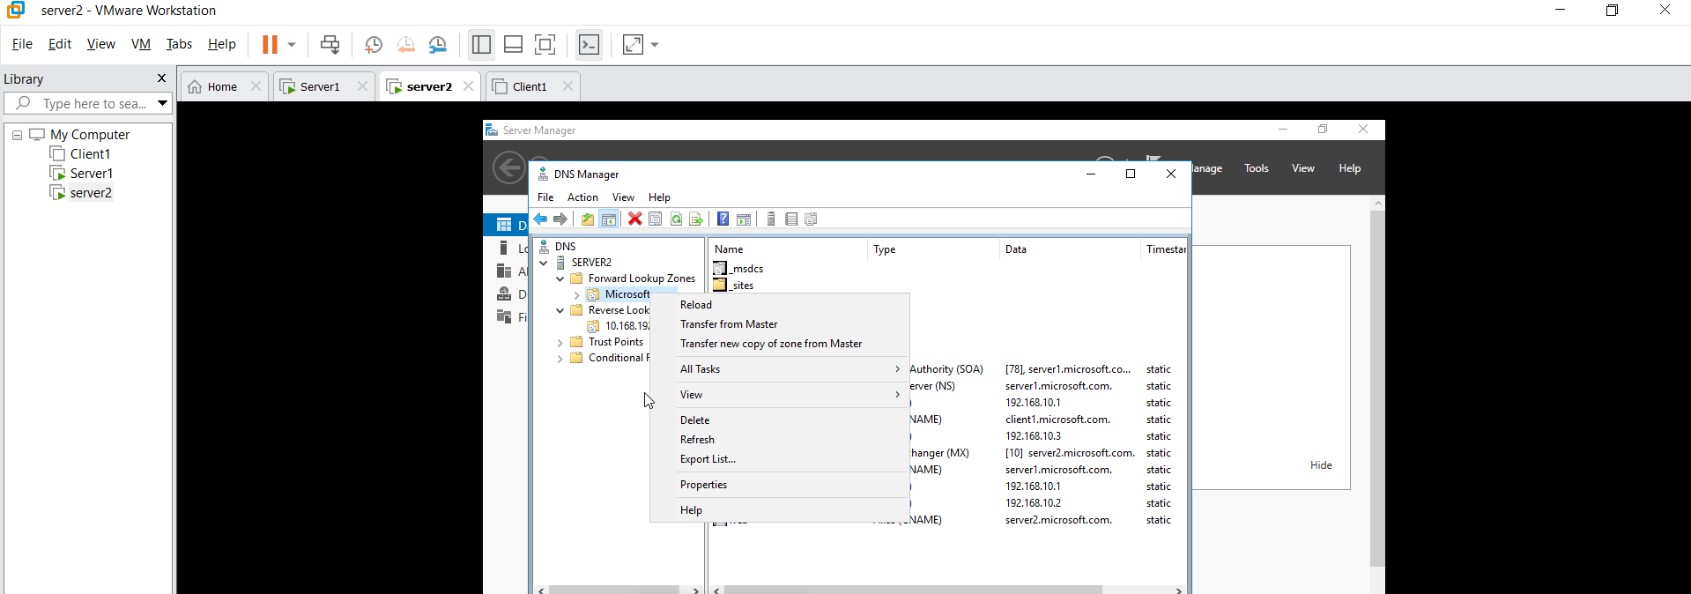

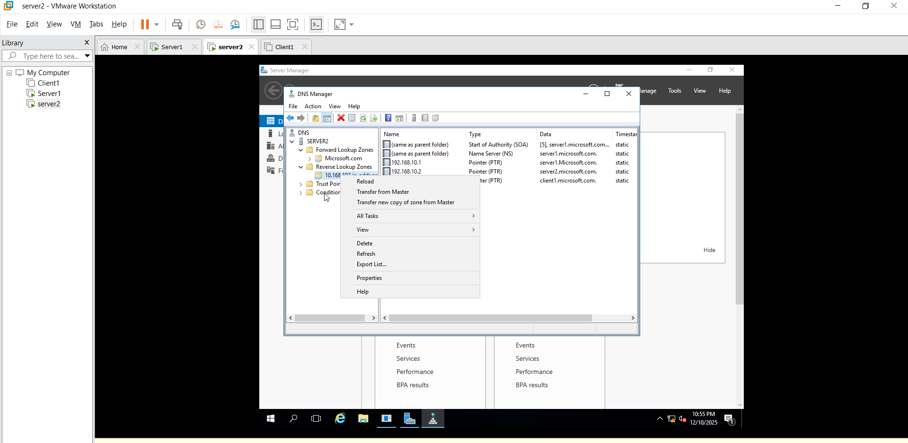

Server 1 new Mail Exchange email server2.m.com

Go to the Server2 :
Server 2 wait 15 min refresh Microsoft.com email

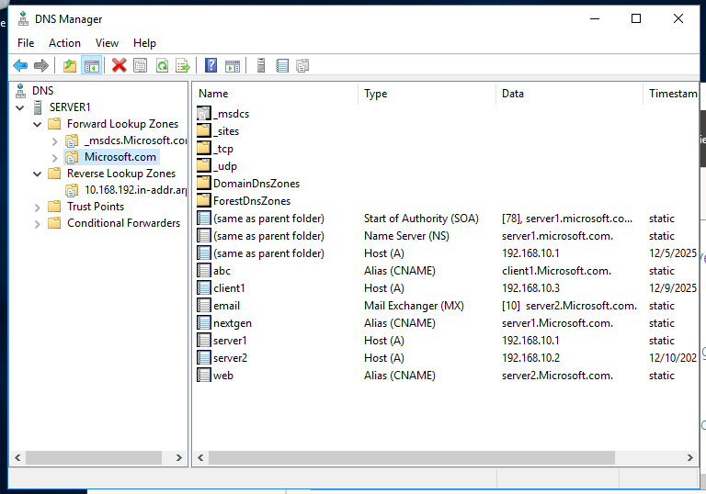

Server 1 new Alias (CNAME) abc Client1

Go to the Server2 :
Server 2 wait 15 min refresh Microsoft.com abc


Server1 Forword Zone Microsoft.com Properties SOA –-> serial number
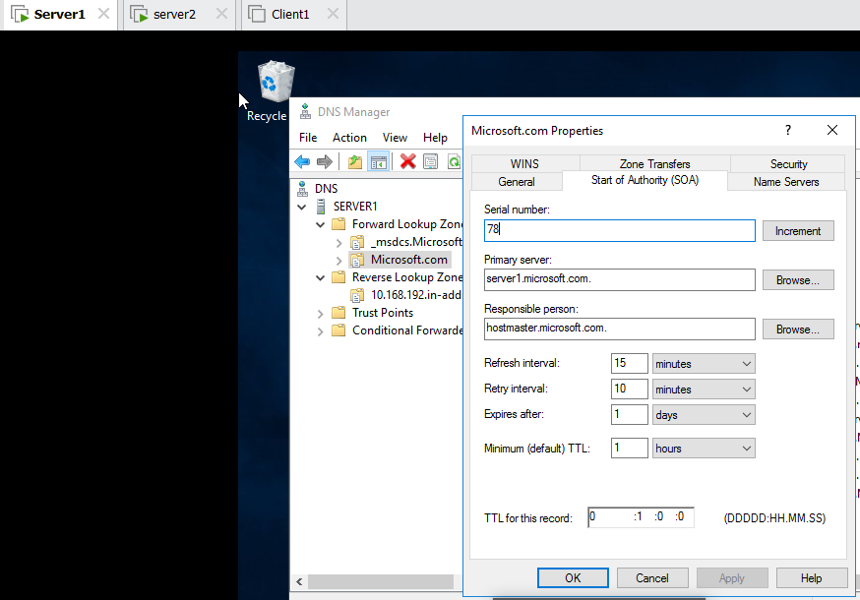
Server2 Forword Zone Microsoft.com Properties SOA –-> serial number

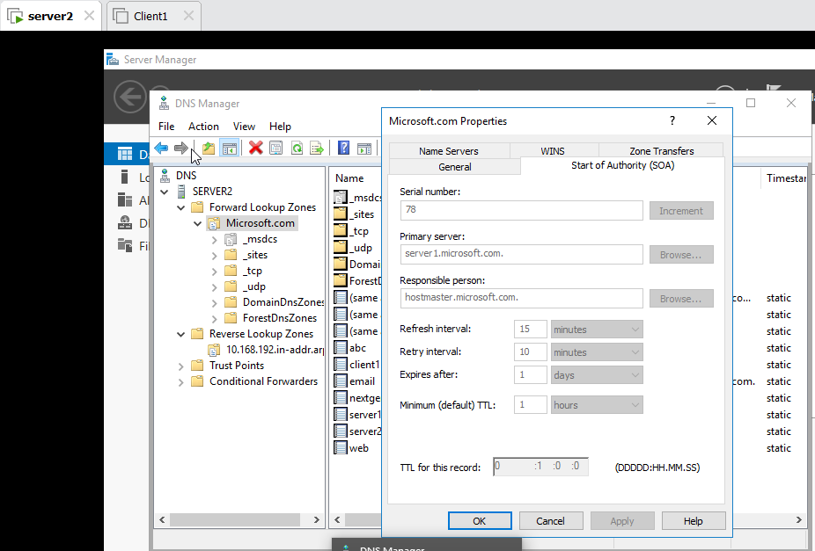

Serial number is same for sever1 and server2 file is transfer from server1 to server2 and vice versa.

